Bealtaine Dawn Chorus Flagship Choir 2024
  - Deadline 5pm, Monday 20th November, 2023
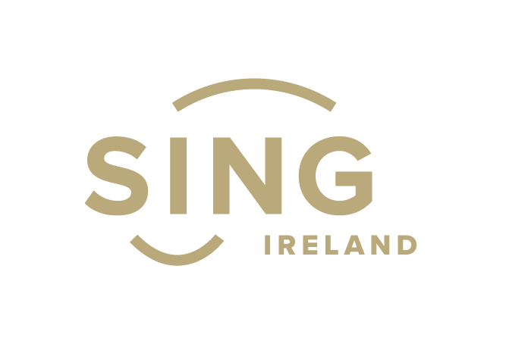

Application Form

Please read the guidelines before completing the following application form. The final application form should be emailed to the Age & Opportunity Arts Administrator, Jessica Burton-Restrick arts@ageandopportunity.ie no later than 5pm, Monday 20th November, 2023.

Name and address of choir:

Name of main contact:
Phone number of main contact:
Email of main contact:
Please confirm your choir is available for one event in May. Dawn events are usually the first Sunday in May. Please indicate the time that would suit you best i.e. 8am. Please explain the reasons for your choice. (100 words)
Tell us a little bit about your choir – when it formed, the style, make-up of the choir, and any performances? (200 words)
Have you or your choir been involved in Bealtaine before? If yes, please give brief details (200 words)
What is your vision for the event in your locality, considering the following headings? (500 words max )
Proposed idea for the event

Location (e.g. a scenic location outside)

Audience

Promotion of event locally

Local partners (e.g. do you have links with your local Arts Office, Age Friendly Programme Manager, and any other relevant organisations?)

Additional funding (e.g. could your Arts Office help with funding for live musicians or other elements that would enhance the event?)

Why should your choir be the Bealtaine Flagship Choir for 2024? (200 words)
Use this space to tell us anything else you feel is relevant to your application. (200 words)

Do you have any photos or video of previous events? If so, please include no more than 3 photos or videos alongside your completed application form. Please do not email video files but instead include a link where we can view it (on YouTube, Vimeo, Facebook etc.)

Insert links here:

